Name:

2.5 Genetics | Objectives
2.5.2 - 2.5.3 Gene Expression | - Define the term gene  - Outline the role of a gene  - Define the term gene expression  - Know the structure of a chromosome
2.5.4 + 2.5.14.H DNA structure | - Outline the complex structure of DNA double helix  - Name the four bases and the base pairs in DNA  - Discuss the bonding in the DNA molecule  - Distinguish between coding and non coding structures  - Define triplet base code  - Outline the structure of RNA  - Name the bases in RNA  - Discuss the replication of DNA
2.5.4 DNA Profiling | - Discuss the stages involved in DNA profiling  - Define the process of DNA profiling  - Give two uses of DNA profiling  - Define and give the use genetic screening
2.5.5 + 2.5.15.H Protein Synthesis | - Know that genes control cell activities by producing proteins  - Know that DNA makes proteins  - Know that DNA carries instructions as a code  - Know that DNA and RNA bases work in groups of three  - Understand that the DNA helix can unzip  - Understand that RNA bases attach to the unzipped DNA  - Know that the RNA strand formed in this way is mRNA  - Know the function of a ribosome in protein synthesis  - Understand the process of translation that leads to the formation of a new protein  - Know that the shape of a protein determines its function  - Outline the steps in protein synthesis  - Discuss the role of mRNA  - Be familiar with complimentary bases in the formation of mRNA  - Know that proteins are made in the ribosomes  - Detail the process of transcription including the role of tRNA  - Know that each protein folds into the correct shape

Genes are the basic unit of heredity.
A gene is a certain length of the chromosome, which contains a certain sequence of base pairs, which codes for a particular protein.
The parts of the DNA that code for a particular protein are called exons. DNA = deoxyribonucleic acid
Non-coding parts of the chromosome are called junk genes or introns. Introns can be found within a gene and between genes. It is this highly variable part that is used in DNA profiling.
Chromosomes are made up of DNA + protein, but genes are made up of DNA alone.

Structure of DNA (Watson & Crick)
DNA molecule consists of a double helix (like a spiral ladder).
It is made up of units called nucleotides. A nucleotide consists of a nitrogenous base, joined to a 5-carbon sugar, joined to a phosphate.
4 Bases = guanine(G), cytosine(C), adenine(A), thymine (T). Base pairs: G ≡ C, A ≈ T form the steps in the ladder. AG = purines and CT = pyrimidines.

DNA differs from RNA as follows:
DNA | RNA
Double helix (strand) | Single strand
Sugar = deoxyribose | Ribose
Base = Thymine | Uracil
Location: In nucleus | In nucleus and cytoplasm
Longer in length | Shorter
Self-replicating | Replicated from DNA

DNA replication
Occurs in the nucleus during interphase of mitosis and meiosis.
Energy (ATP) and the enzyme DNA polymerase are needed for DNA replication.
- The double helix opens - it untwists and unzips (hydrogen bonds broken by enzymes) prior to replication.
- Free nucleotides enter nucleus from cytoplasm.
- New nucleotides form a new chain. Each strand acts as a template to make the opposite strand from complementary nucleotides.
- Each new DNA molecule is ∴
  - half new and half old, (b) identical to the original and each other.
- Each new piece of DNA rewinds to form a double helix.
Identical helices are formed i.e. the original DNA molecule makes 2 exact replicas of itself.

Replication of DNA is necessary to pass on genetic code/information exactly from generation to generation.

DNA PROFILING (DNA fingerprinting)
DNA profiling is a method of making a unique pattern of bands from the DNA of a person, which is used to distinguish that DNA from other DNA.
- DNA is extracted from cells e.g. blood or semen by breaking up the cell membrane.
- DNA amplification can be used if the quantity of DNA is low. Increasing the quantity is done by a technique called the polymerase chain reaction (PCR).
- Restriction enzymes are used to cut the DNA wherever a specific base sequence occurs (mostly junk genes which are highly variable). This base sequence occurs at a different set of positions in everyone. The sets vary in size (length) and number.
- Gel electrophoresis - the fragments are separated, using an electric current, along a piece of gel. The smaller the fragment the faster they travel along the gel.
- The DNA is then transferred onto a nylon membrane for ease of use. The fragments are made visible by attaching radioactive pieces of DNA to them that produce a bar-code-like design on an X-ray film.

DNA profiles can be used to identify criminals from crime scenes or fathers in paternity cases.

GENETIC SCREENING
Testing for the presence or absence of a gene. A single gene is looked for to see if a person is carrying that gene that could be passed onto their offspring e.g. gene for cystic fibrosis.

Protein synthesis
Cell proteins (e.g. enzymes, and in cell membranes) are produced by the use of a template on which the amino acids are ‘lined-up’ in their correct sequence before being joined together by a common enzyme.

Transcription
The transfer of genetic information from the nuclear DNA to the mRNA is known as transcription.

- The DNA unwinds and opens.
- A single-stranded mRNA is formed from complimentary RNA nucleotides which line up along the DNA and are joined together by RNA polymerase. Uracil used instead of thymine.
- mRNA leaves the nucleus and goes to the ribosome.

Translation
Translation is the conversion of the code in mRNA into the amino acid sequence in a protein.
- rRNA binds mRNA to the ribosome.
- tRNAs carry amino acids to the mRNA on the ribosomes.
- Each tRNA, with its anticodon, binds with complimentary codons on the mRNA.
- The amino acids are lined up in their correct sequence and joined together by a peptide bond.
- tRNAs separate and return to the cytoplasm.
- The polypeptide folds to form a 3D functional protein.

Types of RNA
- mRNA is a single stranded copy of the genetic code.

- rRNA
Each ribosome is half protein and half rRNA. Some rRNAs are involved in the binding of the mRNA to the ribosome and some function as enzymes in linking each new amino acid to the chain of amino acids.

- tRNA – in cytoplasm.
It has an anticodon – 3 bases at one end and a specific amino acid at the other end.

2.5.4 DNA Structure, Replication, Profiling & Nucleic Acid Structure
SEC Sample Paper HL
2. Select the correct term from the following list to match each of the terms in column A and write it in
column B.

protein, enzyme, uracil, sap, ethanol, mutation, thymine, chlorophyll.

A | B
DNA
Ribosome
RNA

2004 HL
13. (a) Copy the diagram into your answer book and then complete it to show the complementary base
pairs of the DNA molecule. Label all parts not already labelled. (9)
(b) The genetic code incorporated into the DNA molecule finds its expression in part in the formation of protein. This formation requires the involvement of a number of RNA molecules. List these RNA molecules and briefly describe the role of each of them. (24)

2005 HL
8. (b) As part of your practical activities you extracted DNA from a plant tissue. Answer the following
questions in relation to this experiment.
(i) What plant did you use? …………………………………………………………………..
(ii) It is usual to chop the tissue and place it in a blender. Suggest a reason for this.
(iii) For how long should the blender be allowed to run? ……………………………….………...
(iv) Washing-up liquid is normally used in this experiment. What is its function?
(v) Sodium chloride (salt) is also used. Explain why. ………..……………………………………
(vi) What is a protease enzyme? ……………………………………………………………………
(vii) Why is a protease enzyme used in this experiment? …………………………………………...
(viii) The final separation of the DNA involves the use of alcohol (ethanol). Under what condition is the alcohol used? …………………………………………………………………………….
2005 HL
10. (b) (iv) What is meant by genetic screening?
(v) Parents who are suspected of being carriers of disease-causing alleles may be advised to consider a genetic test. Suggest a role for such a test after in-vitro fertilisation.

2006 HL
7. (b) In the case of each of the following state:
1. An investigation in which you used it,
2. The precise purpose for its use in the investigation that you have indicated.

(iii) Cold alcohol (ethanol)

2007 HL
10. (a) (i) The DNA molecule is composed of two strands held together by paired bases.
1. Which base can link only to thymine?
2. Which base can link only to cytosine?
(ii) Name the type of bonding which occurs between members of a base pair. (9)

(b) (i) Explain what is meant by the term DNA profiling.
(ii) Give a brief account of the stages involved in DNA profiling.
(iii) Give two applications of DNA profiling.
(iv) What is genetic screening? (27)

(c) “The same amount of DNA is present in nuclei of cells taken from the liver, heart, pancreas and
muscle of a rat.”
(i) Use your knowledge of DNA and mitosis to explain this statement.
(ii) Name a cell produced by the rat which will contain a different amount of DNA in its nucleus to those mentioned above.
(iii) Briefly outline how you isolated DNA from a plant tissue. (24)

2008 HL
14. (b) (i) DNA is made of units called nucleotides. Draw a labelled diagram of a nucleotide to show
its three constituent parts.
(ii) Which of the labelled parts in your diagram in (i) may vary from nucleotide to nucleotide?
(iii) The genetic code is contained within the DNA of chromosomes. Briefly describe the nature of this code.
(iv) What is meant by non-coding DNA?
(v) Give one structural difference between DNA and RNA.

2010 HL
8. (b) For which purpose did you use each of the following in the course of your practical studies?
(iii) 1. Washing-up liquid or other detergent while extracting DNA from plant tissue.
2. Freezer-cold ethanol while extracting DNA from plant tissue.
2010 HL
10. Part (a) deals with DNA structure and replication.
(a) (i) Name the base in DNA that pairs with cytosine.
(ii) What are the two main events in the replication of DNA? (9)

2011 HL 9
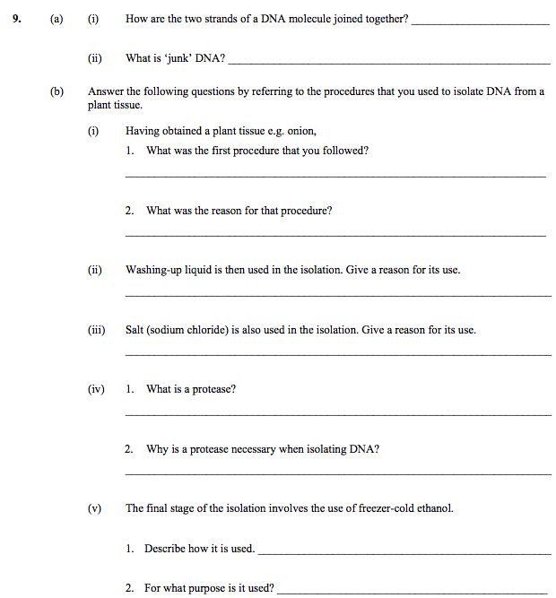

2012 HL 10(a)
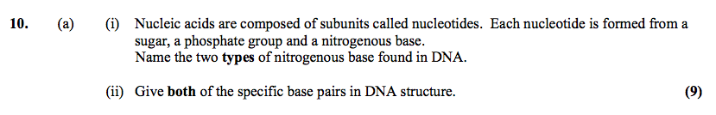

2013 HL 6

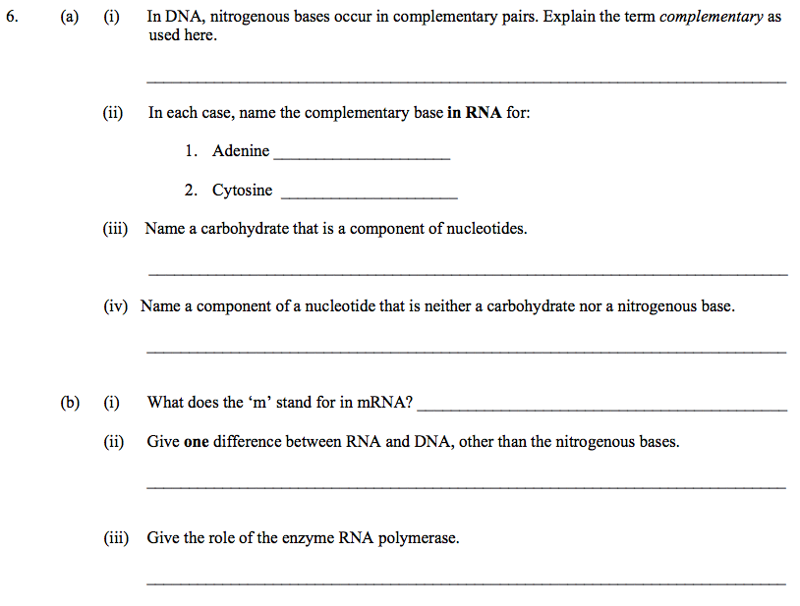
2014 Q10
2015 HL 7(a)(b)

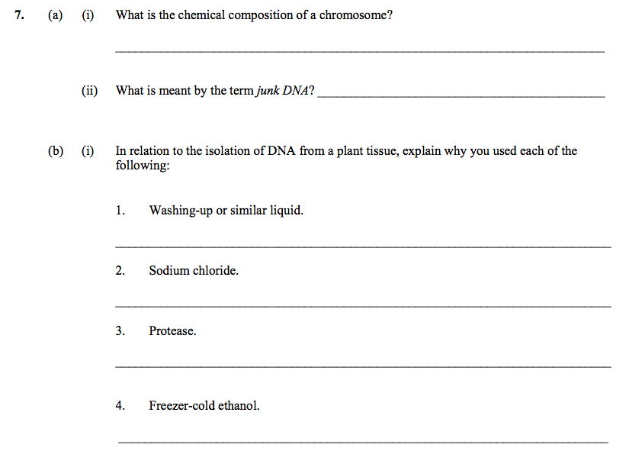

2015 HL 10(b)
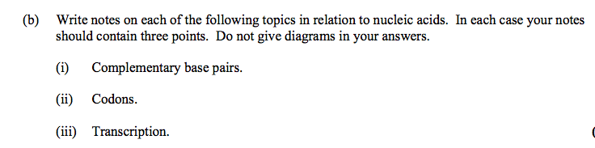

2017 HL 9(b)

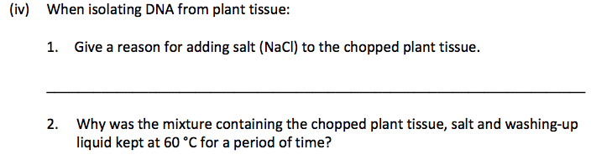
2017 HL 12
HL 2018
13. (a) Most organisms contain both nucleic acids, RNA and DNA.
- (i) Name the biologically active entities, each of which contains only one type of nucleic acid.
- (ii) Name two locations in eukaryotic cells where RNA but no DNA is found.
2.5.5 + H.2.5.15 Protein Synthesis
SEC Sample Paper HL
11.
(c) Answer the following in relation to protein synthesis.
(i) Outline the main events of transcription.
(ii) What is a triplet? State the role of a triplet.
(iii) Describe the role of tRNA. (24)

2005
8. (a) Explain each of the following terms in relation to DNA.
(i) Replication ……………………………………………………………………………………
(ii) Transcription …………………………………………………………………………………
2010 HL
10.
Part (b) deals with protein synthesis.
(b) (i) Explain the terms transcription and translation.
(ii) In which structures in the cell does translation occur?
(iii) How many bases in sequence make up a codon in mRNA?
(iv) Each mRNA codon specifies one of three possible outcomes during protein synthesis.
Name these three possible outcomes.
(v) What does the letter ‘t’ stand for in tRNA?
(vi) During translation one end of a tRNA molecule attaches to an mRNA codon.
What is usually attached to the other end of the tRNA molecule? (27)

DNA answers

2.5.4 DNA Structure, Replication and Profiling

2004 HL Sample Q2
6(3)+2
A | B
DNA | Thymine
Ribosome | Protein
Vacuole | Sap
Fermentation | Ethanol
RNA | Uracil
Active Site | Enzyme
Variation | Mutation

2004 HL Q13
13. | (a) |  | Completed diagram showing two additional sugar molecules and two more bases  diagram completed correctly or shapes of bases or show bonding  new bases named and matched  deoxyribose or phosphate labelled | 3, 0  3, 0  3, 0
 | (b) |  | mRNA(messenger RNA)  rRNA (ribosomal RNA)  tRNA (transfer RNA)  Functions:  mRNA: mRNA formed to match DNA (or transcription or explained) / leaves nucleus or into cytoplasm / (carries instructions) to ribosomes or for translation  rRNA: rRNA binds (holds) mRNA in place / for translation (or explained) / structure of ribosome  tRNA: tRNA carries an amino acid / complementary to mRNA / to ribosomes  any five functions  [must be at least one point from each RNA type] | 3  3  3  5(3)

2005 HL Q8
8 | (b) | (i) | Name of plant | 3
 |  | (ii) | Break up of cell (walls) or release of cytoplasm | 3
 |  | (iii) | A few seconds only (max 6 secs) | 3
 |  | (iv) | To break down membrane(s) or membrane components | 3
 |  | (v) | Clumps (protects) DNA / to remove protein / separates DNA / separates protein | 3
 |  | (vi) | Breaks down (acts on) protein | 3
 |  | (vii) | Proteins are associated with DNA (histones or chromosomes) | 3
 |  | (viii) | (Ice) cold | 3

2005 HL Q10
10 | b | (iv) | Testing (people) for the presence of a (specific) gene | 3
 |  | (v) | Selection of embryo or any valid role | 3

2007 HL Q7
7.
 | (a) | (i) | biological or organic or metabolic or protein catalyst or explained | 3
 |  | (ii) | keratin or myosin or other correct | 3
 | (b) | (i) | name of enzyme | 3
 |  | (ii) | name of matching substrate | 3
 |  | (iii) | pH or substrate concentration or enzyme concentration [allow amount] | 3
 |  | (iv) | buffer or same volume or same amount | 3
 |  | (v) | water baths or described or water bath at different temperatures or  described | 3
 |  | (vi) | time / change e.g. colour, foam, etc  or data logger / sensor named | 2(3)
 |  | (vii) | activity varies with temperature or reference to activity at a particular temperature | 3

2006 HL Q7
7 | b | (iii) | 1. isolation of DNA  2. to separate DNA | 3  3

2007 HL Q10
10. | (a) | (i) | 1. adenine*  2. guanine* | 2(3)
 |  | (ii) | hydrogen (bonding) | 3
 | (b) | (i) | examining DNA / for a pattern or band / to compare | 2(3)
 |  | (ii) | DNA extracted or explained / DNA cut into fragments / using enzymes /  fragments separated / on basis of size / pattern analysed | 4(3)
 |  | (iii) | forensic science or explained / relationships or explained / medical or  explained | 2(3)
 |  | (iv) | to establish presence or absence of gene(s) | 3
 | (c) | (i) | chromosome contains DNA  mitosis maintains same chromosome number or cells derived from mitotic division | 3  3
 |  | (ii) | gamete or sex cell or named | 3
 |  | (iii) | chop plant into small pieces / add salt / add detergent / warm to 50 – 60 degrees / then cool / blend / any one correct time point / filter / add protease / add cold ethanol | 5(3)

2008 HL Q14(b)
 | (b) | (i) | Diagram  labels: deoxyribose or ribose, phosphate, base or named base | 3  3(2)
 |  | (ii) | Base or named base | 3
 |  | (iii) | three bases (triplet or codon) / in sequence / (codes for) one amino  acid /(base or triplet or codon) sequence / codes for protein | 3(3)
 |  | (iv) | does not code for a protein or for RNA  [allow not part of the genetic code or explained] | 3
 |  | (v) | (DNA) contains thymine or RNA contains uracil | 3
 |  | (vi) | Mitochondrion or chloroplast | 3

2010 HL Q8
8 | b | (iii) | - (Detergent) breaks down membranes  - To separate (or see) the DNA | 3  3

2010 HL Q10
10. | (a) | (i) | *Guanine | 3
 |  | (ii) | (DNA) opens (or unzips) / new strands (made) | 2(3)

2011 HL 9

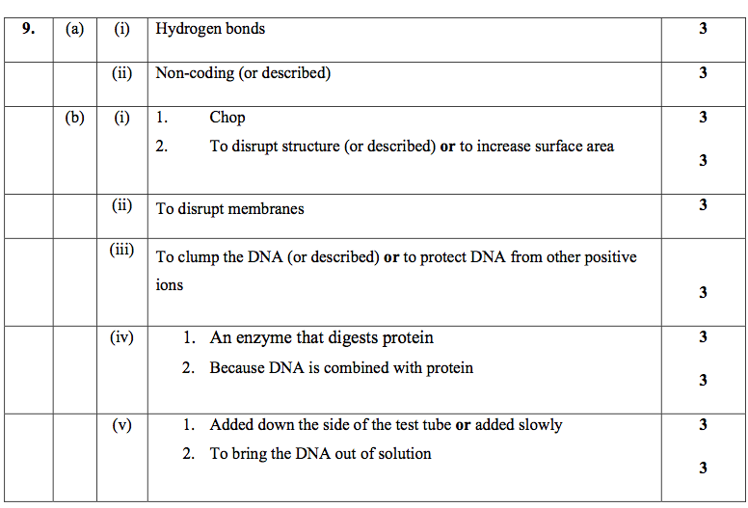

2012 HL 10(a)
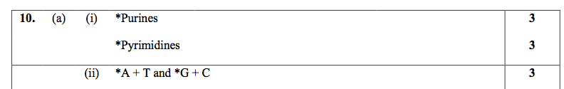

2013 HL 6
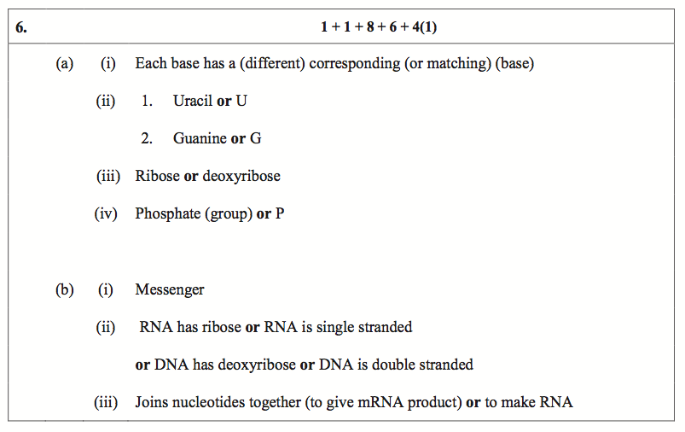
2014 Q10

2015 HL 7

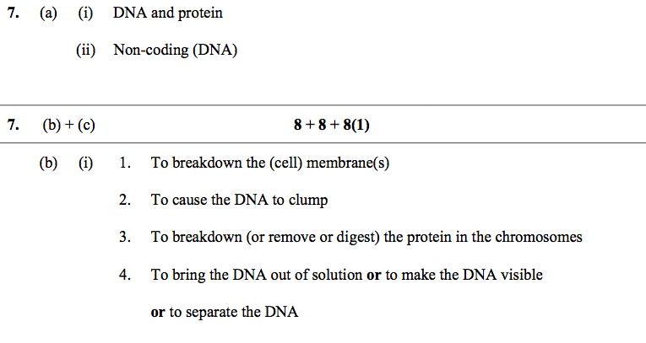2015 HL 10(b)
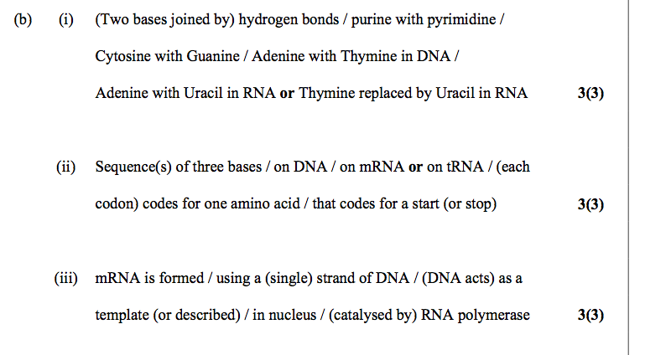

2017 HL 9(b)
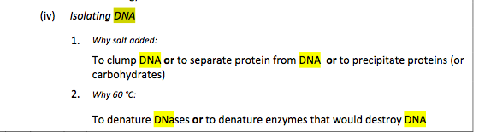

2017 HL 12(a)(c)
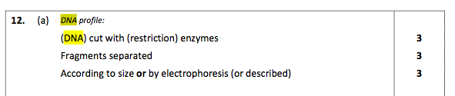

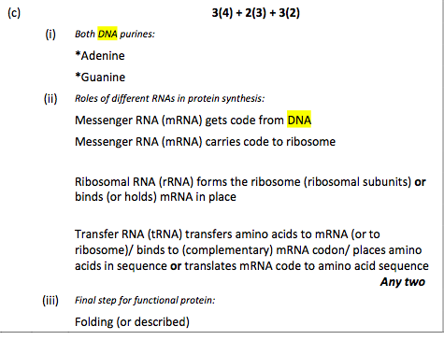
HL 2018
13. (a) Most organisms contain both nucleic acids, RNA and DNA.
- (i) Name the biologically active entities, each of which contains only one type of nucleic acid.
- (ii) Name two locations in eukaryotic cells where RNA but no DNA is found.

Protein synthesis

2005 HL Q8
8. | (a) | (i) | Making a copy | 3
 |  | (ii) | (Matching) RNA production  (notion of both DNA and RNA must be given) | 3

2010 HL Q10
10. | (a) | (i) | *Guanine |  | 3
 |  | (ii) | (DNA) opens (or unzips) / new strands (made) |  | 2(3)
 | (b) | (i) | Transcription:  Translation: | making of (m)RNA using DNA (template)  making a protein using (m)RNA (code) | 3  3
 |  | (ii) | *Ribosome(s) |  | 3
 |  | (iii) | *Three |  | 3
 |  | (iv) | Start;  Adding an amino acid;  Stop |  | 3  3  3
 |  | (v) | *Transfer |  | 3
 |  | (vi) | *An amino acid |  | 3

2004 HL Sample Q11
11 | (c) | (i) | The DNA molecule untwists at the site of the gene/ the message is copied (transcribed) into messenger RNA/ using RNA polymerase/ transcription occurs in the nucleus | 3(3)
 |  | (ii) | Three bases in sequence, e.g. GAC. Triplet codes for a specific amino acid | 2(3)
 |  | (iii) | tRNA carries an amino acid/ complementary to mRNA/ to the ribosome | 3(3)

SEC Sample Paper OL
11. (a) (i) What is meant by the term DNA profiling?
(ii) State two uses of DNA profiling. (9)

(27)
2004 OL
3. RNA is not found in ribosomes T F

2004 OL
12. (c) (i) What is meant by DNA profiling?
(ii) Describe briefly how DNA profiling is carried out.
(iii) Give two uses of DNA profiling. (24)

2005 OL
13. (b) (i) Name the four bases that are found in DNA.
(ii) These bases form a triplet code. What is meant by a triplet code?
(iii) The triplet code is transcribed into mRNA. What does this statement mean?
(iv) To which structures in the cell does mRNA carry the code? (24)

2008 OL
5. The diagram represents a part of a DNA molecule. A and C represent nitrogenous bases.

Complete the following in relation to DNA.
(a) Name the nitrogenous bases whose first letters are A and C.
A _____________________________ C ________________________________
(b) The structure labelled X is called a _________________________________________________
(c) Where in the cell would you expect to find most DNA? ________________________________
(d) DNA contains the instructions needed to make protein.
These instructions are called the _________________ code.

2009 OL
11. (c) (i) What is meant by DNA profiling?
(ii) In DNA profiling, what are used to cut DNA strands into fragments?
(iii) On what basis are these fragments then separated?
(iv) Give two applications (uses) of DNA profiling.
(v) Name the plant from which you isolated DNA in your practical studies.
(vi) For what precise purpose did you use freezer-cold ethanol (alcohol) in your isolation of DNA?
(24)
2010 OL
7. In one of your laboratory activities you isolated DNA from a plant tissue.

(ii) What is meant by DNA profiling?
(b) (i) Give one reason why you first chopped the plant material into very small pieces.
(ii) Detergent and salt were added to the chopped plant material, which was then heated.
Explain why the detergent was used. ______________________________________________
(iii) How was this mixture heated?
(iv) Why was this mixture heated?
(v) Later in the activity the mixture was blended for a maximum of 3 seconds.
What would happen to the DNA if the mixture was blended for longer than 3 seconds?
(vi) Protease was then added to the mixture.
Why was protease added?
(vii) The mixture was then filtered.
After filtration, where was the DNA of your plant tissue to be found?
(viii) What should you do next to make the DNA visible?
2010 OL
11. (c) The diagram shows a short section of a DNA molecule.
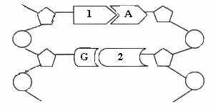
(i) Name the bases numbered 1 and 2 in the diagram above.
2.5.5 Protein Synthesis
2007 OL
4. (d) In order to make proteins, DNA is first transcribed as messenger ………………………………….
2007 OL
7. (a)
(ii) Where in a cell are enzymes produced? ………………………………………………
2010 OL
11. (c) The diagram shows a short section of a DNA molecule.
(ii) Protein synthesis involves both transcription and translation.
Where in a cell does transcription occur?
(iii) What type of RNA is involved in transcription?
(iv) In what organelle does translation occur?
(v) Name the small biomolecules that are joined together to make a protein.
(vi) What must happen to the newly formed protein before it can begin to work? (24)

2004 OL Sample Q11
11. | (a) | (i) | Examining DNA / for a pattern or band / to compare | 3
 |  | (ii) | Forensic / paternity case s/ medical or examples | 2(3)

2004 OL Q3
3. |  |  | 2(5)+5(2)
 |  | F

2004 OL Q12
12 | (c) | (i) | (to look at) an organism’s pattern of DNA fragments  or genetic fingerprinting or (preparing) a pattern of DNA fragments | 6
 |  | (ii) | cells are broken down / how cells are broken down / DNA is released/ DNA is cut into fragments / by (restriction) enzymes / the fragments are separated / on the basis of their size any four | 4(3)
 |  | (iii) | forensic/ paternity/ medical or examples any two | 2(3)

2005 OL Q13
13 | (b) | (i) | adenine, thymine, guanine, cytosine or letters A,T,G,C | 4(3)
 |  | (ii) | three bases / code for one amino acid | 3
 |  | (iii) | information (code) is copied to RNA molecule | 3
 |  | (iv) | ribosome | 6

2008 OL Q5
5. |  |  |  | 2(7)+3+2+1
 | (a) | adenine/ cytosine
 | (b) | triplet/codon / (part of) a gene / genotype [allow nucleotide]
 | (c) | nucleus/ chromosome (allow gene)
 | (d) | Gene / genetic (allow any term implying inheritance)

2009 OL Q11
11 | (c) | (i) | Making a pattern / explanation / accept (Genetic) Fingerprinting  Any one | 6
 |  | (ii) | Enzymes | 3
 |  | (iii) | Size / allow mass /weight / use of gel electrophoresis | 3
 |  | (iv) | Crime(forensic) / Medicine / Paternity / Archeology / Evolution  Any two | 2(3)
 |  | (v) | e.g. Onion | 3
 |  | (vi) | To separate the DNA | 3

2010 OL Q7
7. | (a) | (i) | Nucleus or chloroplasts or mitochondria |  | 5+1
 |  | (ii) | Analysing or examining a person’s DNA (to compare patterns with  others) or getting or providing, patterns or bands
 | (b) | (i) | To increase surface area or to burst cells or to break cell walls | 2(6)+6(2)
 |  | (ii) | To break down cell membranes or to burst cells
 |  | (iii) | In a water bath
 |  | (iv) | To inactivate enzymes
 |  | (v) | It would be shredded
 |  | (vi) | To digest the protein (in the chromosomes) [allow ‘to unravel  DNA’]
 |  | (vii) | In the filtrate or liquid or solution or test tube
 |  | (viii) | Add freezer-cold ethanol or alcohol [allow ‘ice-cold ethanol or  alcohol’]

2010 OL Q11
11 | (c) | (i) | 1. Thymine or T  2. Cytosine or C | 2(6)+6(2)
 |  | (ii) | Nucleus
 |  | (iii) | Messenger or m (RNA)
 |  | (iv) | Ribosome
 |  | (v) | Amino acids
 |  | (vi) | It must fold (into its functional shape)
 |  | (vii) | One function

2007 OL Q4
4 | (d) | RNA

2007 OL Q7
7 | a | (ii) | Ribosome | 3

2010 OL Q11
 | (c) | (i) | 1. Thymine or T  2. Cytosine or C | 2(6)+6(2)
 |  | (ii) | Nucleus
 |  | (iii) | Messenger or m (RNA)
 |  | (iv) | Ribosome
 |  | (v) | Amino acids
 |  | (vi) | It must fold (into its functional shape)
 |  | (vii) | One function

